Manila Community Center & Disc Golf Course
  - By: Matthew Savoie, Dalton Williams
  - 25th of April, 2016

Abstract
The Manila Community Center is a park located in Manila California. This park contains multiple different recreational facilities for local residents. Currently, the park management company does not have any high resolution digital images outlining the facilities that are offered. The purpose of this project is to locate new high resolution, digital images to update the maps for the Manila Community Center and to create digital shapefiles for use in management of the park. Through the creation of shapefiles, we will perform an analysis to determine the area of each facility, as well as the distance between objects, and elevation changes for the disc golf course.
After analysis was completed, we created a series of shapefiles for the Manila Community Center to utilize in their park management activities, as well as calculated valuable data on each feature located within the park. This data will be provided to the Manila Community Services District for their use in online and print materials.

Introduction
The Manila Community Center is a park facility located in Manila California. This park contains multiple different recreational activities for local residents. The park contains: a baseball field, tennis courts, a basketball court, tetherball, campsites, playground and even a disc golf course. The management organization for the park does not currently have a digitized map that outlines all of the parks features clearly (Manila Community Services District). As for their maps for the disc golf course, they are outdated and utilize a blurry satellite image. It also lacks direction and metrics about the individual features.
The goal of this project is to create updated maps for the Manila Community Services District to use in their management of the park, as well as update their print maps and online material. We will also provide them with a hard copy of the digitized files for them to incorporate into their management practices. This project is to create high resolution, mid-level accuracy for the each of the recreational activities that the park has to offer, grouped into four individual maps.
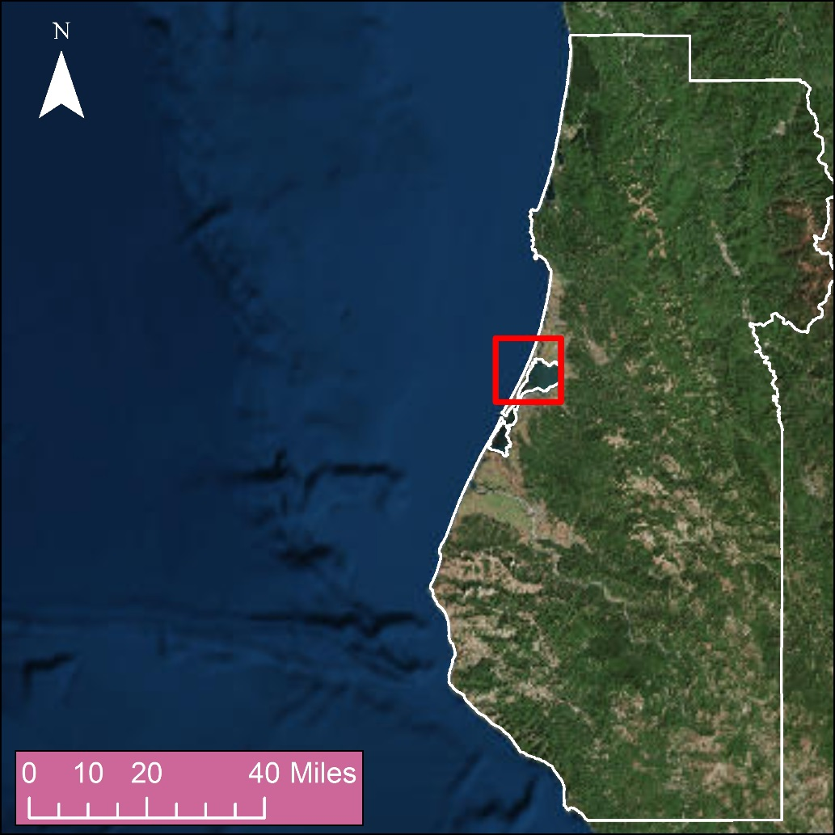
Figure 1 Map showing the general location of Manila within Humboldt County, California. (ESRI 2016, Humboldt County 2004).

Methods
We decided that we wanted to create maps with Geographic Information Systems, GIS for short, information about the infrastructure at the Manila Community Center. To achieve this, we would need the following GIS information and more: Disc Golf Tee locations Shapefile (Point), Basket and Basket Alternative locations Shapefile (Point), Footpaths between baskets Shapefile (Polyline), Parking area Shapefile (Polygon), Roads Shapefile (Polyline), Playground Shapefile (Polygon), Tennis Court Shapefile (Polygon). We were unable to find this information online so we had to capture it in the field by our global positioning system, or GPS. We used the waypoint average function on the GPS so that web could avoid as much error as possible. Once the data was loaded into the ArcMap GIS Software we compared our locations with a basemap from Esri, Inc, some of the points were adjusted so that they aligned better with the visible structures of the basemap. We chose the basemap from Esri because it contained clear 30cm resolution imagery, where as other satellite imagery was blurry or in lower resolutions. From there we created new shapefiles connecting our points in to polygons or polylines and edited the symbols so that they were distinct from each other. Analysis was done to calculate the distance from the Tees to the Baskets, the area of the different polygon features, and the count of sedentary point types. We also calculated the number of available parking spaced in the parking lots since the paint had worn off. To do this we used the equation: $Count=\left(\frac{Area-\left(\left(0.25\right)Area\right)}{90}\right)$.

Results
The physical counts in units of the sedentary points are summarized table one below. The summary of elevation change between each basket and tee off is shown in table 2.
Table 1: Summary of park features.
Feature | Area in Square Feet | Physical Count
Parking lot | 26,523.5 | 61 Parking Spaces
Basketball Court | 7,827 | N/A
Tennis Court | 20,786.6 | 2 Courts
Campsites | 9,683 | 10 Spots
Bathroom | 785.5 | N/A
Playground | 16,967 | N/A
Baseball Field | 121,461 | N/A
Grandstands | 3,600 | N/A
Tetherball | N/A | 2 Poles
Benches | N/A | 13
Fire Pit | N/A | 7
Trashcan | N/A | 9
Signs | N/A | 4
Utilities | N/A | 3
Fire Hydrant | N/A | 1
Water Fountain | N/A | 2

Table 2: Summary of distance and elevation change between tee off zones and the basket or alternative basket.
Disc Golf Tee | Basket/Alternate Basket | Distance in Feet | Elevation Change (+/- ft.)
1 | Alternate | 212 | -21
1 | Basket | 284 | -29
2 | Alternate | 390 | 5
2 | Basket | 346 | -1
3 | Basket | 147 | -6
4 | Basket | 174 | -3
5 | Basket | 294 | -9
6 | Alternate | 253 | -6
6 | Basket | 280 | -4
7 | Alternate | 198 | 11
7 | Basket | 272 | 10
8 | Alternate | 243 | -6
8 | Basket | 299 | -3
9 | Basket | 240 | 0

There is a map that focuses on the: Campsite location (figure 3), playground and surrounding facilities (figure 2), the baseball field (figure 4), and the disc golf course (figure 5). Each one of these maps clearly layout what the park has to offer local residents and where each feature is located. The last map we created, figure 6, is a large scale map that contains all of the individual features of the park combined into one large composite informative map. This map shows the location and label for every feature located within the Manila Community Center.

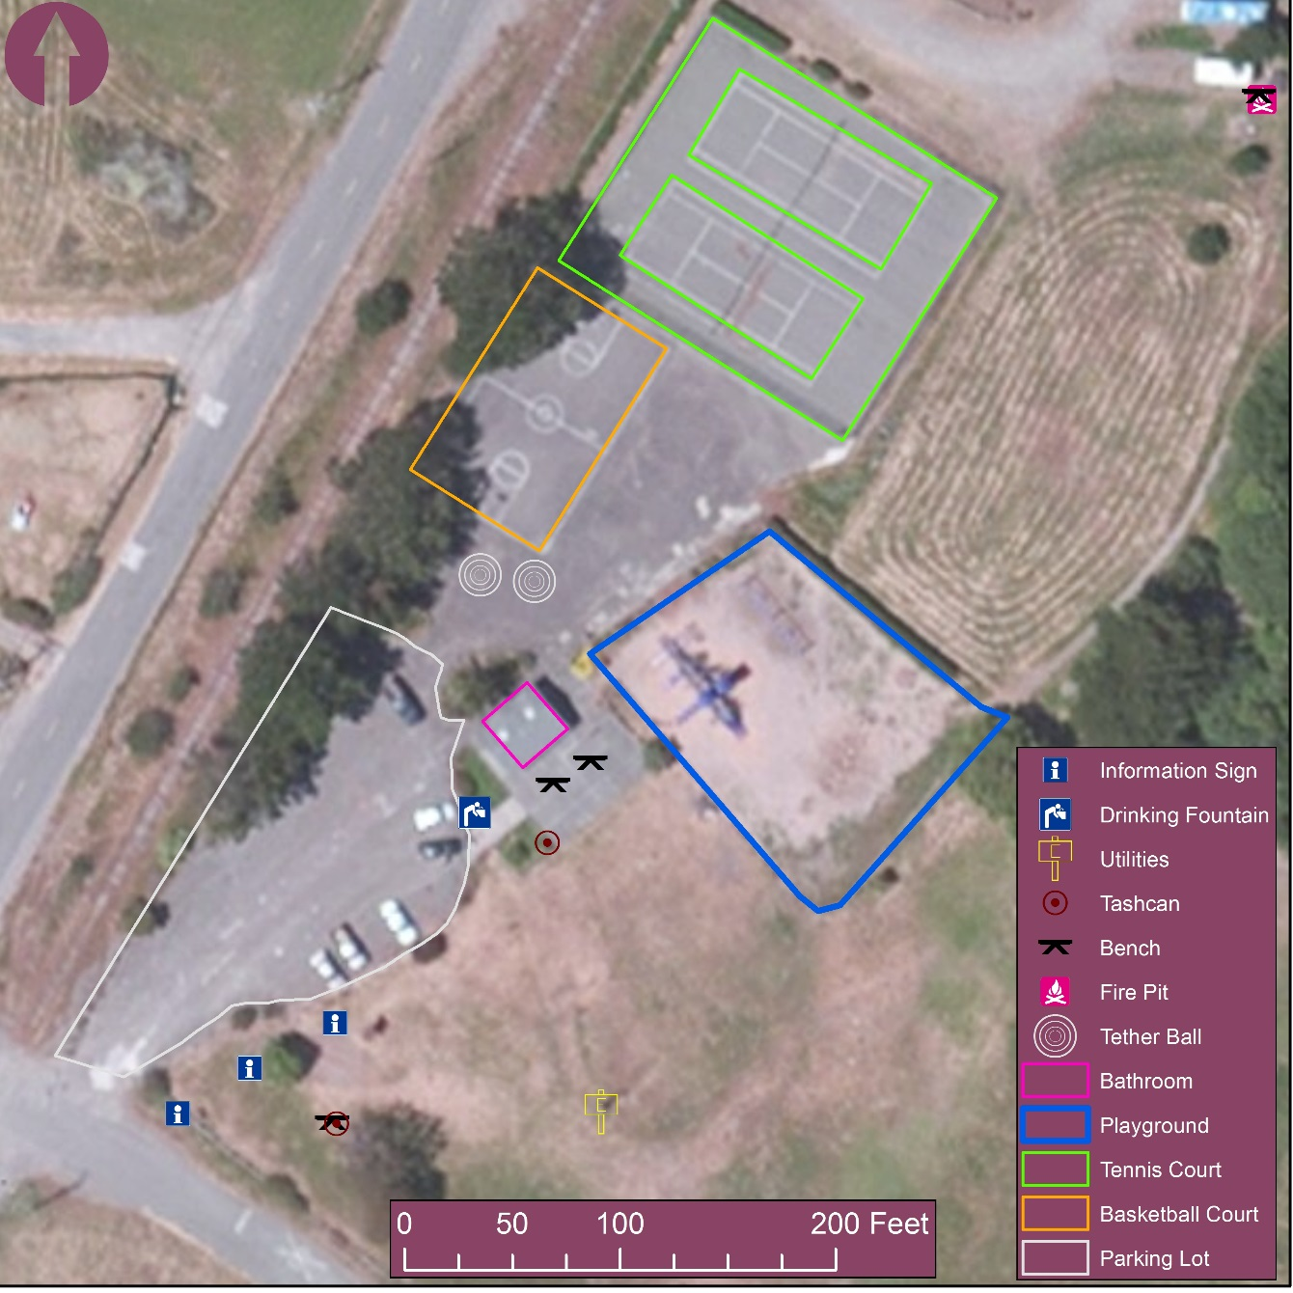
Figure 2: Community Center playground information. (Base map Source: ESRI, 2016)
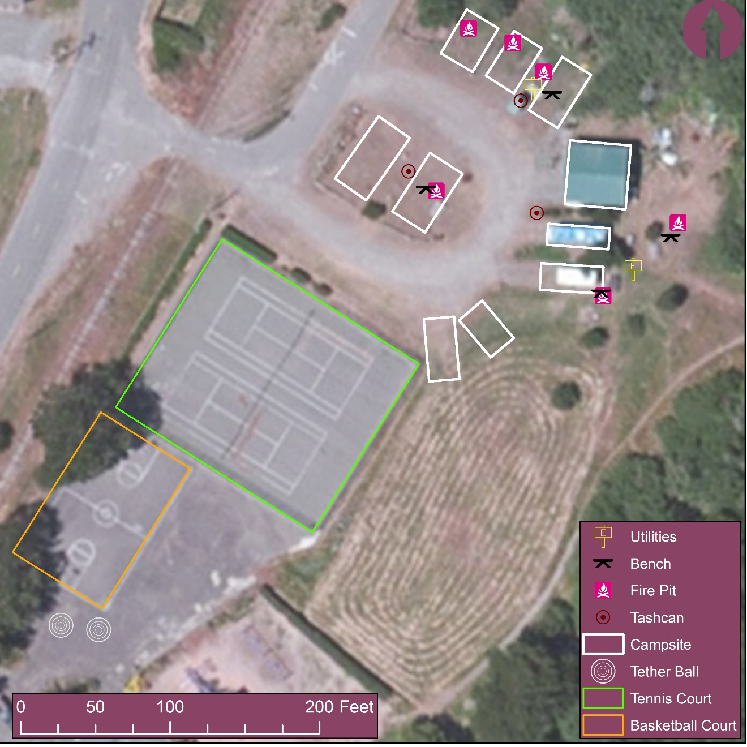
Figure 3: Campsites within the Community Center. (Base map Source: ESRI 2016)
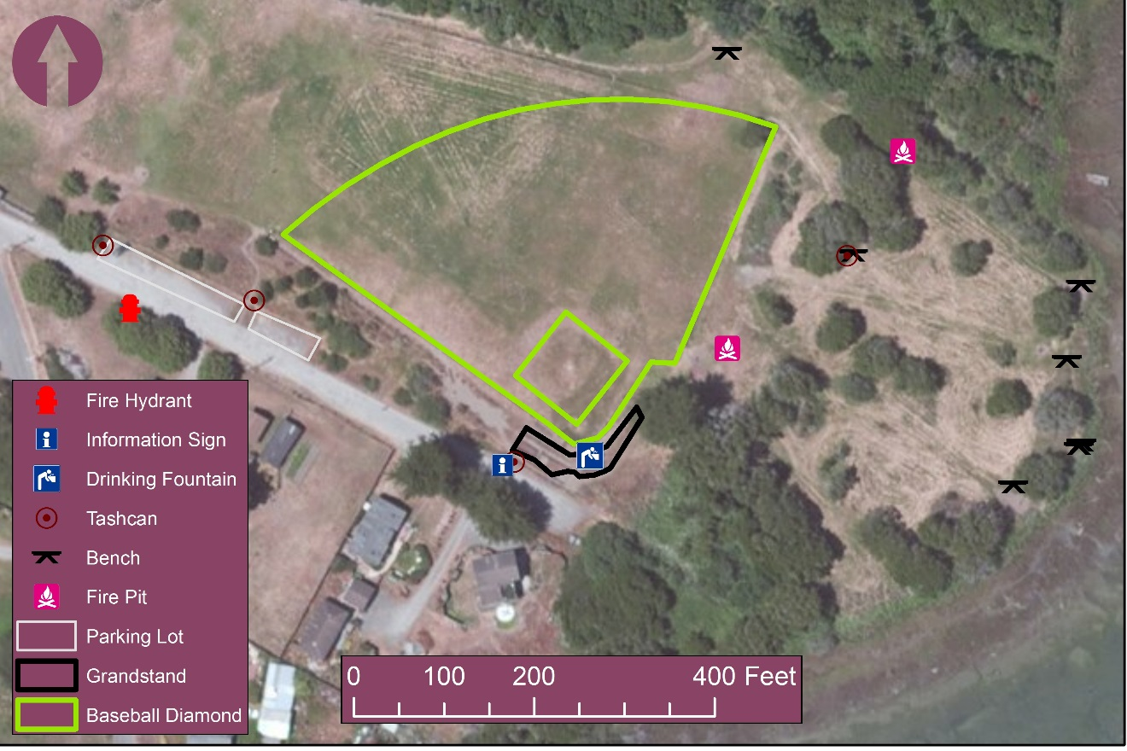
Figure 4: Baseball Field, picnic tables, and fire pits within the Community Center. (Base Map Source: ESRI 2016)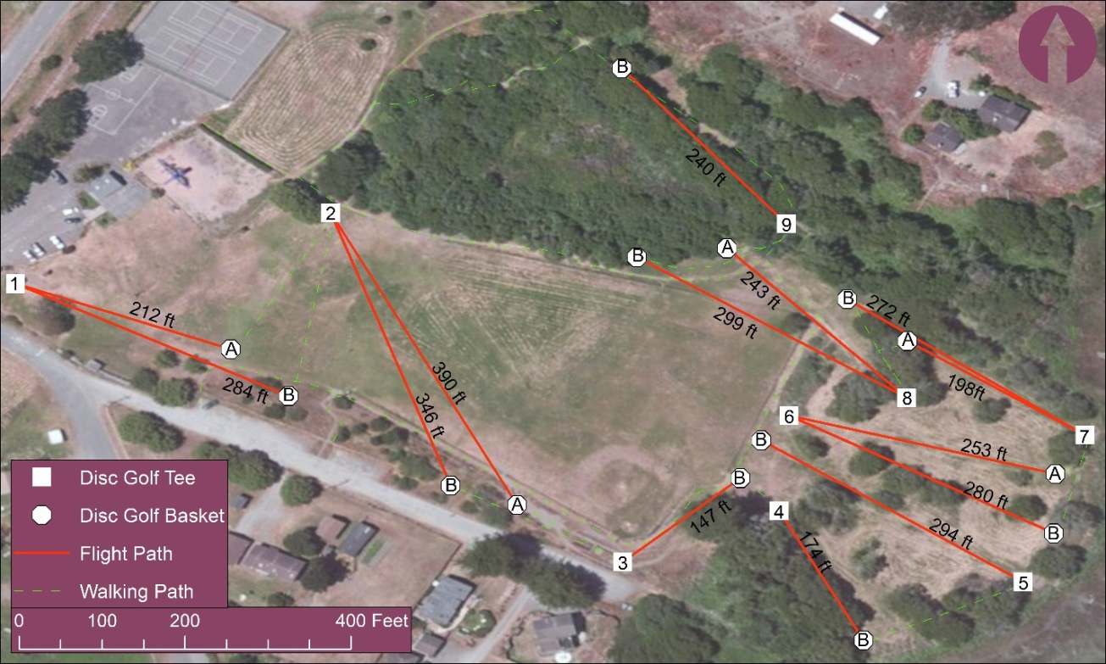
Figure 5: Disc Golf Course holes 1-9, B represents basket, A stands for alternate basket. (Base Map Source: ESRI 2016)
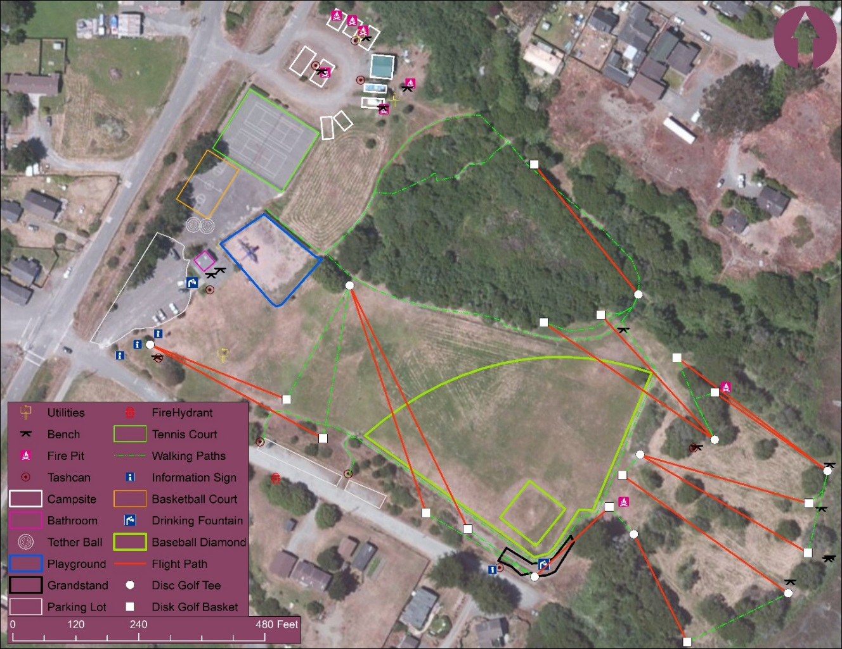
Figure 6: Complete map of the entire Manila Community Center. (Base Map Source: ESRI 2016)

Conclusion
This report shows that the Manilla Community Center has many activities to offer users of all ages. We hope that creating these maps will help with the management and development of the area. Immediate actions that we would recommend to improve the area based on our analysis would be; to re-paint each parking area with the number of spaces that we computed, improve the disc golf signage so that it at a minimum includes distances to the basket and whether or not the basket is in the A or B position, and development of the baseball field to clearly mark where the outfield boundary would be. If there is error in our analysis it would have first come from the individual GPS units while recording data in the field and then in any transformation/computation step that took places with ArcMap.

Acknowledgements
Data for this study were provided by the Humboldt County GIS Department, as well as: Esri, DigitalGlobe, GeoEye, Earthstar Geographics, CNES/Airbus DS, USDA, USGS, AEX, Getmapping, Aerogrid, IGN, IGP, swisstopo, and the GIS User Community Funding. Computer access, Garmin GPS units, and other facilities were provided by Humboldt State University. Shapefiles created by Matthew Savoie, and Dalton Williams. Report template provided by James Graham.

